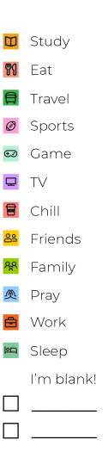Study timetable

|  |  |  |  |  |  |  |  |
| --- | --- | --- | --- | --- | --- | --- | --- |
|  | Monday | Tuesday | Wednesday | Thursday | Friday | Saturday | Sunday |
| 6am |  |  |  |  |  |  |  |
| 7am |  |  |  |  |  |  |  |
| 8am |  |  |  |  |  |  |  |
| 9am |  |  |  |  |  |  |  |
| 10am |  |  |  |  |  |  |  |
| 11am |  |  |  |  |  |  |  |
| Midday |  |  |  |  |  |  |  |
| 1pm |  |  |  |  |  |  |  |
| 2pm |  |  |  |  |  |  |  |
| 3pm |  |  |  |  |  |  |  |
| 4pm |  |  |  |  |  |  |  |
| 5pm |  |  |  |  |  |  |  |
| 6pm |  |  |  |  |  |  |  |
| 7pm |  |  |  |  |  |  |  |
| 8pm |  |  |  |  |  |  |  |
| 9pm |  |  |  |  |  |  |  |
| 10pm |  |  |  |  |  |  |  |